Premiere Pro Interface Layout
Label the Premier Pro Interface:
Name
A.
B.
C.
D.
E.
F.
G.
H.

Project Panel (Shift+1):
Define:
Importing Methods:

How do we Import a Folder:
Describe Bins:
How do we create a bin:
How do we rename bins & media:
What are the 2 View types::

What does the new item button do:

- Project Panel Icons:
List View | Icon View | Indicates
 | 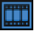
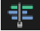
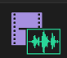
 | no icon

Project Panel (Shift + I):

Define:
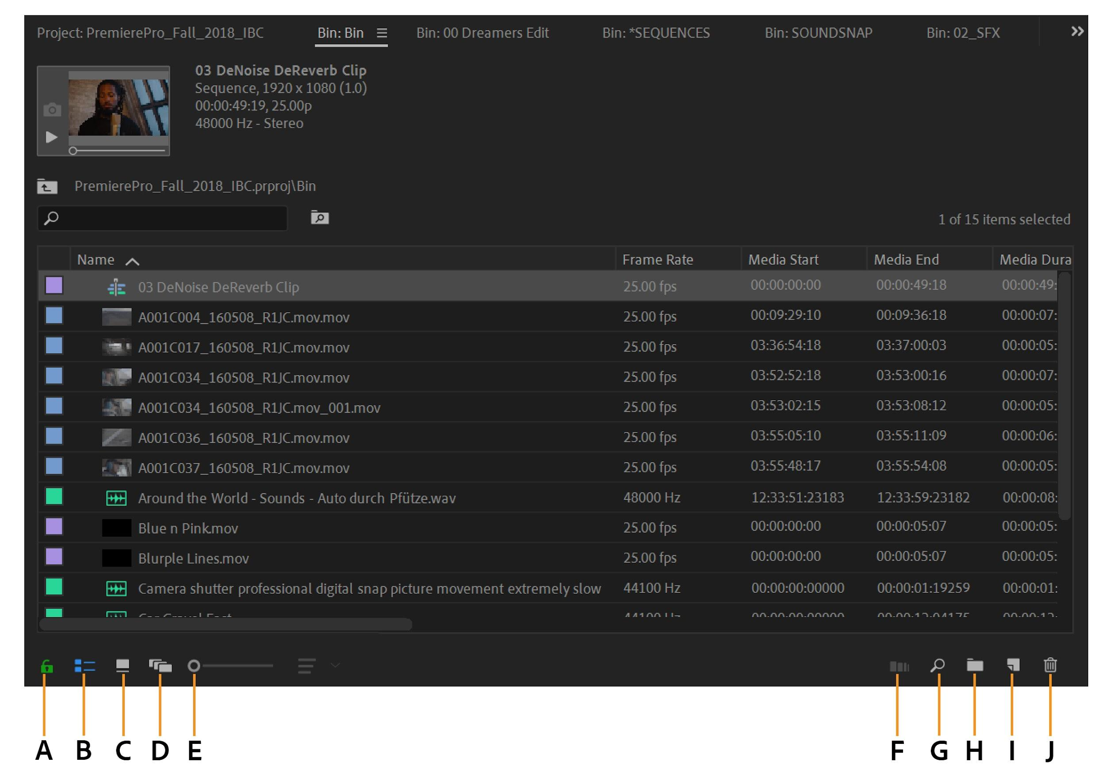
Label the parts of Project Panel:
A.
B.
C.
D.
E.
F.
G.
H.
I.
J.

Source Monitor Panel (Shift+2):

Define:
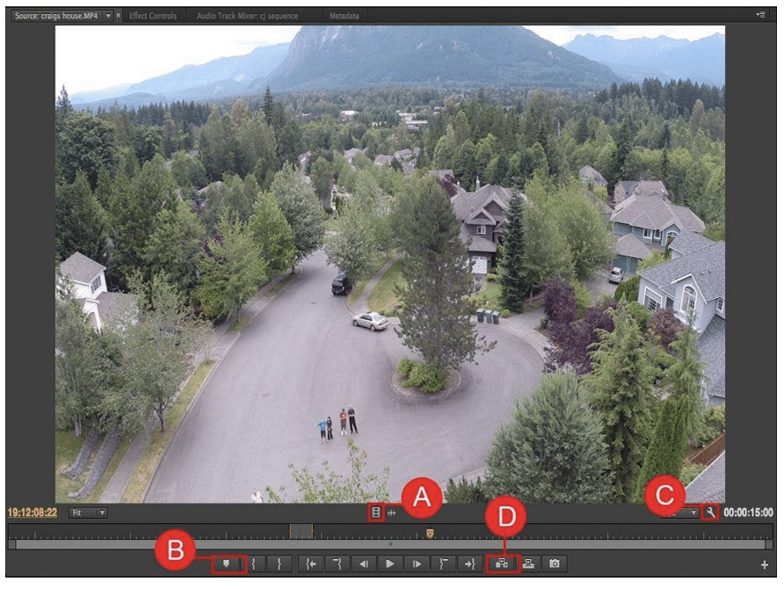
Label the Parts of the Source Monitor Panel: Part 1
A.
B.
C.
D.

Label the Parts of the Source Monitor Panel: Part 2
A.
B.
C.
D.

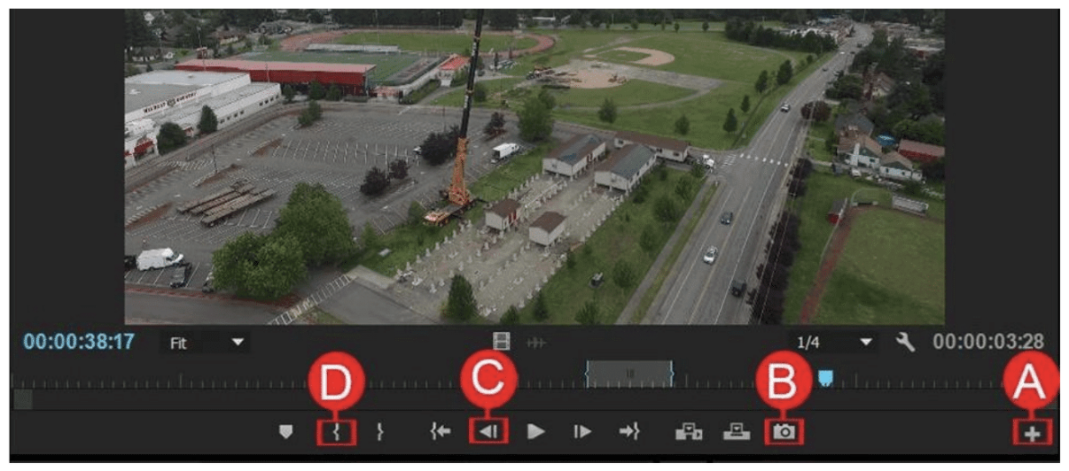
Label the Parts of the Source Monitor Panel: Part 3
A.
B.
C.
D.

Timeline Panel (Shift+3):
Define:
CTI:
How do we read Timecode:
Shortcut to Show All Clips on your timeline:
What is the default # Tracks for video & audio:
How do we Expand Track:
Describe Audio Rubber Band:
How do we Unlink/Link Audio & Video:
How do we access Clip Speed/Duration:
Keyboard shortcuts for reviewing video:
What is Ripple Delete:
How do we Rename a Track:

Label the Parts of the Timeline Panel: Part 1
A.
B.
C.
D.

Label the Parts of the Timeline Panel: Part 2
A.
B.
C.
D.

Program Monitor Panel (Shift+4):
Define:
Similar to Source Monitor, except for:
Lift:
Extract:
Safe Margins:
Source Monitor vs. Program Monitor
Source:
Program:
Markers:

Lift
Extract
Safe Margins

Effect Controls Panel (Shift+5):  Define:  By default each clip has:  - Video:  - Motion:  - Opacity:  - Time remapping:  - Audio:  - volume  Keyframes:  Toggle Animation: | 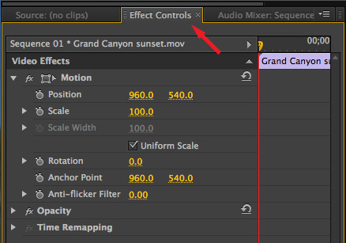
Effects Panel (Shift+7):  Define:  How to Apply Effects:  Default Video Transition:  Default Audio Transition:  Shortcut to Apply Default Transition:  Dip to Black: | 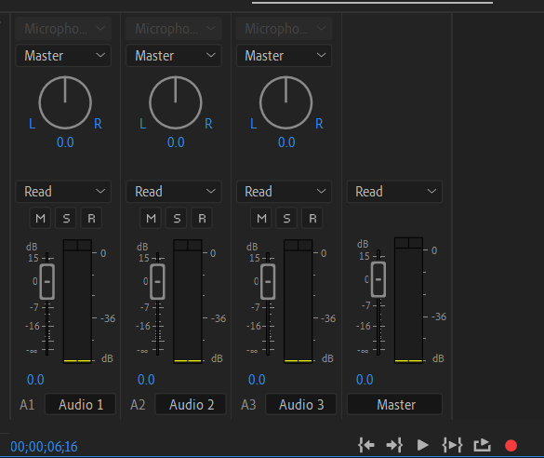

Audio Track Mixer Panel (Shift+6):
Define:
List Sliders:

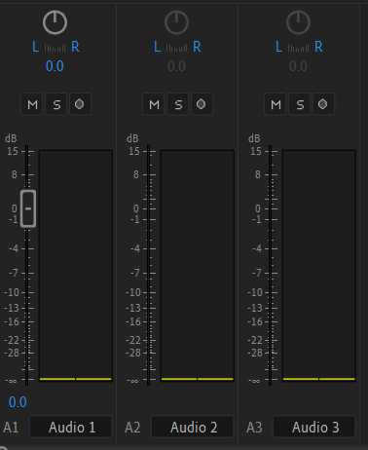
Audio Clip Mixer Panel (Shift+9):
Define:
List Sliders:

Audio Level Meter:
Define:

Exporting:
Define:
Shortcut -
What can we Export from our project:
Source Range:
List Still File Formats:
List Video File Formats:
List Audio File Formats:
Output Name:

Label the Export Panel:
A.
B.
C.
D. |  | Define:  What are the options we can select:

